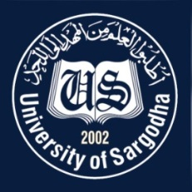 | Faculty Positions on Visiting Basis
Department of Sports Sciences
University of Sargodha
Applications for the following positions are invited from Pakistani nationals for Spring semester 2021.
Teaching Faculty

Sr.# | Positions | No. of Posts | Nature of Post | Eligibility Criteria
1. | Visiting Lecturers  - Physical Education | As per requirement | Visiting Faculty  (Open merit, for Spring semester 2021). | Qualification:-  - MS/M.Phil/ M.A/ M.Sc. in Physical Education
NOTE |  |  | General Information
- As per university policy, the Institute/department reserves the right not to consider any application or fill any post without giving any reason.
- Candidates are required to submit complete latest C.V, two latest Passport Size Pictures and copies of all testimonial documents along with duly filled application form in the Office, of Department of Sports Sciences, Sargodha University.
- Prescribed application form may be downloaded from University website (www.su.edu.pk)
- Applications complete in all respects should reach the Department on or before 01-03-2021 at04:00 P.M.
- Interview of the short-listed candidates will be conducted on 04-03-2021 at10:00 A.M in the office of Incharge, Department of Sports Sciences Sargodha University.
- The applicants having provisional transcript will not be eligible for the visiting faculty
- Applications received after due date will not be entertained.
- Candidates with relevant experience will be preferred.
- Applications should be addressed to Incharge, Department of Sports Sciences Sargodha University
- Online applications will not be accepted.
- Incomplete applications will not be accepted.

Incharge
Department of Sports Sciences
University of Sargodha
Sargodha

